**BLOOD DONATION MANAGEMENT SYSTEM**

**TABLE OF CONTENT**

**introduction**

# CHAPTER ONE

# INTRODUCTION

## 1.1 **BACKGROUND**

Blood donation plays a crucial role in modern healthcare, providing life-saving support for patients undergoing surgery, trauma victims, and individuals suffering from medical conditions such as anemia, leukemia, and severe infections. The World Health Organization (WHO) emphasizes that an efficient blood donation management system is essential to ensure a steady and safe blood supply (WHO, 2020).

In many developing countries, including Burundi, hospitals rely on manual paper-based blood donation records, which result in inefficiencies, data inaccuracy, and slow response times in emergencies. Kibitoke Hospital, a leading healthcare provider in Kibitoke Province, faces serious challenges in managing its blood supply, leading to frequent shortages, wastage of expired blood units, and difficulties in coordinating donors.

The introduction of a Blood Donation Management System (BDMS) will provide real-time blood inventory tracking, donor registration automation, and streamlined hospital request processing. This system will enhance efficiency, data security, and donor engagement, ultimately improving healthcare services and reducing mortality rates due to blood shortages.

## 1.2 **PROBLEM STATEMENT**

Blood donation is a crucial component of modern healthcare systems, ensuring that hospitals and clinics have sufficient blood supplies to perform lifesaving transfusions. However, many healthcare facilities, particularly in developing countries such as Burundi, struggle with ineffective blood donation management. Kibitoke Hospital, which serves a large population in Kibitoke Province, relies on a manual, paper-based system for managing blood donations, blood inventory, and hospital requests. This outdated system results in several critical challenges that affect both hospital efficiency and patient outcomes.

**1.2.1 Inefficient Blood Donor Registration**

The current manual registration process for blood donors at Kibitoke Hospital is slow and error-prone. Hospital staff record donor details on paper forms, which are later stored in physical files. This approach has several drawbacks:

**Difficulty in retrieving donor records** when a hospital requires a specific blood type, finding an eligible donor becomes time-consuming.

**Lack of an automated eligibility check** staff must manually verify if a donor meets the required medical criteria.

**Misplaced or lost donor records** due to poor storage and lack of digitization, records can be lost, leading to donor data inconsistencies.

Studies have shown that automating donor registration significantly improves efficiency. Ahmed et al. (2020) found that hospitals using digital donor management systems reduced registration errors by 35% and improved donor response times by 40%.

**1.2.2 Poor Blood Inventory Tracking and Management**

Kibitoke Hospital’s blood inventory is tracked manually using logbooks, making it difficult to determine real-time stock levels. This leads to the following problems:

**Frequent blood shortages** staff often discover shortages too late, delaying urgent transfusions.

**Blood wastage due to expiration** hospitals sometimes store excess blood without a proper tracking system, leading to expired units.

**Lack of real-time stock updates** hospitals and blood banks cannot coordinate efficiently because there is no centralized database.

Karim & Hossain (2022) studied blood management inefficiencies in Bangladesh and found that hospitals without automated tracking had 50% higher rates of blood wastage compared to those using real-time inventory systems.

**1.2.3 Slow and Ineffective Hospital Blood Requests**

Kibitoke Hospital often experiences delays in processing blood requests from different hospital departments. The current manual request process requires paperwork approval, which can take hours or even days. This has life-threatening consequences in emergency cases where immediate transfusion is needed.

**1.2.4 Low Donor Retention and Lack of Engagement**

One of the biggest challenges at Kibitoke Hospital is low donor retention. Many first-time donors do not return for subsequent donations, leading to constant donor shortages. This is due to:

**Lack of follow-up notifications** the hospital does not have a system to remind donors when they are eligible to donate again.

**Absence of incentives or recognition programs** donors are not engaged or rewarded for their contributions.

**Limited awareness campaigns** there is no efficient method for informing potential donors about urgent needs.

**1.2.5 Security and Data Privacy Concerns**

Since Kibitoke Hospital relies on paper-based records, donor and patient information is vulnerable to loss, theft, or unauthorized access. There is also no data backup system, meaning that a fire, flood, or human error could destroy all records permanently.

**1.2.6 Summary of the Problem**

The manual blood donation system at Kibitoke Hospital is outdated and inefficient, leading to:

Delays in donor registration and verification.

Poor blood inventory tracking, causing shortages and wastage.

Slow hospital request processing, endangering emergency patients.

Low donor retention due to lack of engagement and follow-ups.

Security risks associated with paper-based donor and blood records.

To address these issues, this study proposes the development of a Blood Donation Management System (BDMS) for Kibitoke Hospital. The system will digitize donor records, automate inventory tracking, streamline hospital requests, and improve donor engagement, ultimately enhancing efficiency and saving lives.

1.3 **AIM OF THE STUDY**

The main aim of this study is to design, develop, and implement a Blood Donation Management System (BDMS) for Kibitoke Hospital to enhance efficiency in donor registration, blood inventory tracking, and hospital blood requests.

1.4 **SPECIFIC OBJECTIVES**

1. To develop a donor registration module that records donor details, medical history, and eligibility.

2. To implement a real-time blood inventory tracking system to monitor blood availability and expiration.

3. To create a hospital request module to manage and track blood transfusion requests.

4. To integrate an automated notification system for donor reminders and emergency alerts.

5. To provide data analytics and reports on blood donations, stock levels, and usage trends.

**1.5 Research Questions**

1. How can an automated system improve blood donor registration at Kibitoke Hospital?

2. What impact will real-time blood inventory tracking have on reducing blood wastage and shortages?

3. How can a digital hospital request system improve emergency response times?

4. What role does automation play in increasing donor engagement and retention?

5. How can the system ensure data security and integrity in blood donation management?

1.6 **SCOPE**

1.6.1 **Content Scope**

This study focused on the designing, development, and implementation of a Blood Donation Management System that includes:

Donor registration (capturing donor information and medical history).

Blood inventory tracking (monitoring stock levels and expiration dates).

Hospital request management (ensuring efficient blood distribution).

Automated notifications (reminders for donors and alerts for staff).

1.6.2 **Geographical Scope**

The system is to be implemented at Kibitoke Hospital located in kibitoke province, with future scalability to other hospitals in Burundi.

**1.6.3 Time Scope**

The project is completed within four months, divided into:

✔ 1 Month: Requirements gathering and system design.

✔ 2 Months: System development and testing.

✔ 1 Months: Deployment, staff training, and evaluation.

**1.7 Justification of the Study**

The implementation of a Blood Donation Management System will:

* Improve emergency response times by automating blood requests.
* Enhance donor retention through automated engagement and reminders.
* Reduce blood wastage by providing real-time inventory tracking.
* Increase security and efficiency by eliminating manual records.

By addressing these issues, the system will support life-saving interventions and improve healthcare delivery in Kibitoke Province.

**CHAPTER TWO: LITERATURE REVIEW**

**2.1 Introduction**

Blood donation management is critical in ensuring the availability of safe blood for transfusions. The World Health Organization (WHO, 2021) estimates that blood shortages contribute to 15% of preventable deaths in developing countries, mainly due to inefficient donor management, lack of real-time blood tracking, and manual hospital request processes.

Several researchers have studied the impact of automated blood bank management systems in addressing these challenges. However, existing literature reveals gaps in real-time hospital request integration, donor retention, and security mechanisms, which this study aims to address through a Blood Donation Management System for Kibitoke Hospital.

**2.2 Importance of Blood Donation Management Systems**

Studies have demonstrated that automating blood donation processes improves efficiency, reduces wastage, and increases donor participation.

**Chakraborty et al. (2020)** conducted a study on India’s National Blood Bank System and found that manual record-keeping caused 35% of blood shortages due to mismanagement of donor data. After implementing a centralized database and automated donor tracking, hospitals reported:

✔ 30% faster access to donor eligibility records.

✔ 40% improvement in blood stock management.

✔ 20% reduction in expired blood units.

However, their system lacked mobile accessibility for donors, making it harder for people to register or receive reminders about donation eligibility. This study will incorporate a mobile-friendly platform to enhance donor engagement at Kibitoke Hospital.

**2.3 Existing Blood Donation Systems**

2.3.1 Red Cross Blood Bank System (USA, 2018) – Thomas & Patel (2019)

The Red Cross Blood Bank System is one of the most widely used systems for donor registration and inventory tracking. The system integrates:

✔ A centralized donor database with eligibility tracking.

✔ AI-driven donor matching for rare blood types.

✔ Automated hospital request processing.

**Findings by Thomas & Patel (2019):**

The system increased donor participation by 50% in urban areas due to simplified registration.

Blood shortages were reduced by 35%, improving hospital supply.

Identified Gap:

The system lacks real-time inventory tracking at the hospital level, which can cause delays in emergency transfusions. This study will address this issue by introducing real-time blood stock monitoring for Kibitoke Hospital.

**2.3.2 Smart Blood Bank System (Pakistan, 2020) – Rahman et al. (2020)**

Rahman et al. (2020) evaluated Pakistan’s Smart Blood Bank System, which introduced:

✔ Mobile applications for donor notifications and blood requests.

✔ AI-based donor recommendations to increase turnout.

✔ Cloud-based data storage for accessibility.

**Findings:**

Donor turnout increased by 45% due to mobile notifications.

Blood shortages were reduced by 28% as donors were contacted promptly.

Cloud-based storage improved data security and backup reliability.

Identified Gap:

Despite its advantages, the system lacked inter-hospital coordination, meaning blood exchange between hospitals was difficult. This study will integrate a hospital-to-hospital request feature to enhance resource sharing during emergencies.

**2.3.3 eBlood Donation System (Nigeria, 2021) – Adebayo et al. (2021)**

Adebayo et al. (2021) examined Nigeria’s eBlood Donation System, which introduced:

✔ Real-time inventory tracking to monitor blood stock.

✔ Automated donor reminders for increased participation.

✔ Direct hospital request integration for faster blood allocation.

**Findings**:

Request fulfillment time was reduced by 50%, allowing hospitals to respond quicker to emergencies.

Donor retention increased by 35%, as reminders encouraged repeat donations.

Expired blood units were reduced by 20%, as stock monitoring prevented unnecessary wastage.

Identified Gap:

The system lacked advanced data security measures, making donor information vulnerable to cyber threats. This study will implement encryption and access control to enhance data security in Kibitoke Hospital.

**2.3.4 Automated Blood Bank System (Bangladesh, 2022) – Karim & Hossain (2022)**

Karim & Hossain (2022) analyzed the implementation of Bangladesh’s Automated Blood Bank System, which used:

✔ Online donor registration and automated matching.

✔ Cloud-based data management.

✔ AI-powered demand forecasting.

**Findings:**

Hospitals experienced a 60% reduction in blood wastage, as AI predictions optimized stock levels.

Emergency response time improved by 40%, as real-time inventory data allowed for quick decision-making.

Blood request processing time decreased from 2 hours to 30 minutes.

Identified Gap:

While AI-based demand forecasting improved efficiency, the system did not include personalized donor engagement strategies. This study will integrate an incentive-based donor engagement module to encourage repeat donations.

**2.4 Challenges in Blood Donation Management**

2.4.1 Lack of Real-Time Inventory Tracking

Mahmoud et al. (2020) studied hospitals in Egypt and found that over 25% of blood shortages were due to poor inventory tracking systems. Many blood banks fail to update stock levels in real-time, leading to delays in emergency transfusions.

This study will implement real-time stock monitoring to provide accurate availability updates at Kibitoke Hospital.

**2.4.2 Low Donor Retention Rates**

Smith & Johnson (2019) found that 40% of first-time donors never return, leading to continuous blood shortages. Their research suggested that:

✔ Hospitals with automated donor reminders retained 30% more donors than those using manual follow-ups.

✔ Lack of engagement strategies resulted in high donor drop-out rates.

This study will introduce an automated donor engagement system using SMS/email notifications and incentives to increase retention at Kibitoke Hospital.

**2.4.3 Security and Privacy Concerns**

Gupta & Singh (2021) reported that 35% of healthcare cyberattacks target blood bank databases. Their findings showed that:

70% of manual blood banks lack encryption, making them vulnerable to unauthorized access.

Many existing systems lack secure authentication mechanisms, putting donor and patient data at risk.

This study will implement encryption, role-based access control, and multi-factor authentication to enhance data security at Kibitoke Hospital.

**2.5 Research Gap**

After analyzing existing research, the following gaps were identified:

**Lack of Real-Time Hospital Integration**

Existing systems do not provide real-time blood stock updates at the hospital level.

This study will introduce real-time inventory tracking to ensure accurate availability monitoring.

Poor Donor Engagement and Retention

Many systems fail to retain donors due to lack of automated reminders and incentives.

This study will incorporate an incentive-based donor engagement system to increase repeat donations.

Weak Security Measures in Blood Bank Systems

Several blood donation systems lack robust data security mechanisms.

This study will integrate encryption, access controls, and authentication measures to protect donor data.

**2.6 Summary**

This chapter reviewed existing blood donation systems, their impact, and identified research gaps. While automated blood bank systems improve efficiency, most lack real-time tracking, donor engagement strategies, and strong security measures.

This study will address these gaps by developing a Blood Donation Management System for Kibitoke Hospital, incorporating:

✔ Real-time hospital request tracking.

✔ Automated donor engagement.

✔ Enhanced security features.

**CHAPTER THREE: METHODOLOGY**

**3.1 Introduction**

This chapter outlines the research methodology to be used in the development of the Blood Donation Management System (BDMS) for Kibitoke Hospital. It includes the research design,data collection methods, system development methodology, system requirements, and security considerations. The primary focus of this study is to identify inefficiencies in the current manual blood donation system and develop an automated system to address these challenges.

The study follows a qualitative approach, relying on first-hand data collection from hospital staff, blood donors, and other key stakeholders. The primary data collection methods used include interviews, direct observations, and focus group discussions. These methods help in gathering insights into manual record-keeping challenges, donor retention issues, and hospital blood request delays.

**3.2 Research Design**

The study employs a descriptive research design, which allows for an in-depth understanding of the current blood donation system challenges at Kibitoke Hospital. The research is conducted in three stages:

Understanding the current manual system – Observing how blood donations are registered, stored, and requested.

Collecting data through interviews and focus groups – Gathering first-hand experiences from hospital staff, blood donors, and administrators.

Developing and testing the BDMS – Ensuring the system meets user requirements before full deployment.

**3.3 Data Collection Methods**

The research relies exclusively on primary data collection methods to gain first-hand information on the challenges of manual blood donation processes. The following techniques were used:

**3.3.1 Interviews**

Semi-structured interviews will be conducted with hospital staff, blood donors, and administrators to collect qualitative data on their experiences with the manual blood management system.

**Target Groups for Interviews:**

✔ **Blood Bank Managers:** To understand the challenges in managing donor records, tracking blood stock, and responding to hospital requests.

**✔ Hospital Administrators**: To gain insights into policy-making and decision-making on blood bank operations.

**✔ Doctors & Nurses:** To understand how delays in blood requests affect emergency treatments.

**✔ Donors:** To identify factors influencing donor retention and participation.

**Sample Interview Questions**

**For Blood Bank Managers:**

How do you currently record and manage donor details?

What challenges do you face in tracking blood stock levels?

How do you process hospital requests for specific blood types?

What problems arise due to manual record-keeping?

Would you support an automated system for blood management? Why?

**For Hospital Administrators:**

How does manual blood inventory tracking affect hospital operations?

What challenges do you face in coordinating blood donation campaigns?

Are there cases where blood requests have been delayed due to poor inventory management?

What security concerns do you have regarding donor and patient records?

What features would you like to see in an automated blood donation system?

**For Doctors & Nurses:**

How frequently do blood shortages affect medical treatments?

What is the impact of delayed blood requests on emergency cases?

Have you experienced cases where expired blood was mistakenly used?

How does the hospital currently notify donors when blood is needed?

What improvements would an automated blood request system bring?

**For Blood Donors:**

What motivates you to donate blood regularly?

What challenges have you faced when registering as a donor?

Do you receive reminders or notifications about future donations?

Would a mobile notification system encourage you to donate more frequently?

What improvements would make the donation process more efficient?

**3.3.2 Observations**

The researcher conducted direct observations at Kibitoke Hospital’s blood bank to examine:

✔ How blood donors register and how records are stored.

✔ How blood stock is manually tracked and updated.

✔ How hospital staff process blood requests and manage shortages.

**Key observations included**:

Long processing times for donor registration and hospital requests.

Frequent delays in updating blood stock records.

Misplacement of donor records, making it difficult to track eligibility.

Difficulty in tracking blood expiry dates, leading to wastage.

This information was crucial in designing an automated system that eliminates these inefficiencies.

**3.3.3 Focus Group Discussions**

A focus group discussion will be conducted with hospital staff to gather insights on:

✔ Problems with manual blood request approvals.

✔ Concerns about donor data security and privacy.

✔ Recommendations for an automated system.

The group discussions are expected to provide valuable input on how to make the system user-friendly and improve adoption among hospital staff.

**3.4 System Development Methodology**

The Waterfall Model was chosen as the Software Development Life Cycle (SDLC) methodology, as it allows for clear phase-by-phase development. The system will be developed in five key phases:

**3.4.1 Requirement Analysis Phase**

Identify the key functional requirements based on data from interviews and observations.

Define system objectives, such as real-time blood inventory tracking and automated donor notifications.

**3.4.2 System Design Phase**

Create Entity-Relationship Diagrams (ERD) to define the database structure.

Develop Data Flow Diagrams (DFD) to visualize how data flows in the system.

Design a User Interface (UI) prototype for testing.

**3.4.3 System Development Phase**

**Back end:** Develop using PHP and MySQL.

**Front end**: Design with JavaScript, HTML, and CSS for a user-friendly experience.

**Security:** Implement role-based authentication for data protection.

**3.4.4 Testing and Debugging Phase**

**Unit Testing:** Check individual modules for functionality.

**Integration Testing:** Ensure all modules works together smoothly.

**User Acceptance Testing (UAT):** Hospital staff shall test the system for usability.

**3.4.5 Deployment and Training Phase**

The system shall be installed at Kibitoke Hospital.

Staff will be trained on how to use the system for donor registration and inventory tracking.

**3.5 System Requirements**

**3.5.1 Functional Requirements**

✔ Donor registration and record management.

✔ Blood inventory tracking with expiry date alerts.

✔ Hospital request processing with real-time tracking.

✔ Automated donor notifications and reminders.

✔ Data security with user authentication.

**3.5.2 Non-Functional Requirements**

✔ High system reliability and availability.

✔ Secure encryption of sensitive data.

✔ User-friendly interface for hospital staff.

**3.6 System Testing**

To ensure the reliability of the BDMS, various testing strategies will be used:

**3.6.1 Unit Testing**

Test individual features such as donor registration, blood tracking, and notifications.

**3.6.2 Integration Testing**

Verify that different modules (registration, inventory tracking, and hospital requests) functioned together.

**3.6.3 User Acceptance Testing (UAT)**

Conduct with Kibitoke Hospital staff to ensure usability.

**3.7 Security Considerations**

The system incorporates:

✔ Data encryption to protect donor and hospital records.

✔ Role-based access control to limit unauthorized access.

✔ Automatic data backups to prevent data loss.

**3.8 Ethical Considerations**

✔ Confidentiality**:** Donor information will be protected.

✔ Hospital Approval**:** Ethical clearance shall be obtained from Kibitoke Hospital.

✔ Voluntary Participation:All interview participants consented.

3.9 Summary

This chapter outlined the research methods, data collection techniques, system development process, and security measures used in developing the BDMS. The study relied on first-hand data from hospital staff and donors, ensuring the system meets real-world needs.

**CHAPTER FOUR**

# **SYSTEM ANALYSIS AND DESIGN**

## **4.1 Introduction**

This chapter provides a detailed analysis and design of the **Blood Donation Management System (BDMS)** for **Kibitoke Hospital**. The chapter identifies system requirements, designs appropriate models, and presents diagrams that illustrate how the system functions. The main goal of this phase is to translate user and functional requirements into a technically feasible system design that can be implemented effectively.

## **4.2.1 Functional Requirements**

Functional requirements describe what the system must do. These requirements are derived from interviews with hospital staff, donors, and observation of manual procedures at **Kibitoke Hospital**. The proposed **Blood Donation Management System (BDMS)** will support the following functionalities:

### **1. Donor Registration Module**

This module is fundamental to the system. It enables staff to **collect, validate, and store essential donor details**. Currently, this process is done on paper and prone to loss or damage.

#### Features:

* **Capture Donor Personal Information**:  
  Upon arrival, a new donor will be asked to provide key details such as:  
  ▪ Full name  
  ▪ ID/passport number  
  ▪ Age (donors must be 18–65 years)  
  ▪ Gender  
  ▪ Address (village, zone, commune)  
  ▪ Contact number and email address

These details help the hospital in record-keeping, follow-up, and notifications.

* **Store Medical History and Last Donation Date**:  
  Before accepting a donation, staff will check if the donor has:  
  ▪ Any chronic illnesses (e.g., HIV, hepatitis, anemia)  
  ▪ Low hemoglobin or blood pressure  
  ▪ Recent surgeries, pregnancy, or tattoos  
  The system stores these medical records and also tracks when the donor last gave blood to prevent early re-donation.
* **Assign Donor Eligibility Status**:  
  The system uses programmed logic to assign a status:  
  ▪ **Eligible** – Ready to donate again  
  ▪ **Temporarily Ineligible** – Not yet due or has a temporary condition  
  ▪ **Permanently Ineligible** – Due to chronic illness or age  
  This reduces the chances of errors and unsafe donations.

### **2. Donor Login and Profile Access**

This module allows **self-service for registered donors**, helping reduce paperwork and increasing transparency.

#### Detailed Features:

* **Log In to Check Donation History**:  
  Donors can use their phone number or donor ID and password to log into the system, where they will see a timeline of previous donations with dates, locations, and blood types donated.
* **View Eligibility Status and Next Donation Date**:  
  The system calculates this automatically, displaying a countdown or green indicator when the donor is due.
* **Update Personal Contact Information**:  
  Donors can edit their phone number, email, or address. This ensures the hospital has up-to-date contact info for emergency alerts or upcoming campaigns.

### **3. Blood Inventory Management**

This module helps the hospital monitor and control **blood stock availability**. Manual stocktaking is replaced with **real-time automated updates**.

#### Features:

* **Record Units by Blood Type**:  
  Each donation is labeled and recorded under the correct group (A+, A−, etc.), allowing staff to easily find the right match.
* **Track Expiry Dates and Quantity**:  
  Each blood unit has a shelf life (e.g., 42 days for red cells). The system monitors units and alerts staff when:  
  ▪ Stock is running low  
  ▪ Units are about to expire  
  ▪ Some blood types are overstocked (to avoid wastage)
* **Generate Stock Reports Automatically**:  
  Reports showing current inventory by type, soon-to-expire units, and donation trends can be generated on demand.

### **4. Hospital Request Module**

This module ensures **organized and traceable communication** between hospital departments (e.g., surgery, maternity) and the blood bank.

#### Features:

* **Request Specific Blood Types and Units**:  
  Medical staff can use a digital form to request needed blood types and specify the quantity.
* **Inventory Lookup Before Request**:  
  The system shows current stock so staff can request realistically (e.g., avoid requesting unavailable types).
* **Track Request Status**:  
  Every request passes through these stages:  
  ▪ Submitted  
  ▪ Reviewed by blood bank  
  ▪ Approved or rejected  
  ▪ Dispatched  
  ▪ Fulfilled
* **Audit Trail**:  
  All requests are logged with time, date, department, and person responsible.

### **5. Administrative Dashboard**

This is the **control center** of the system, accessible only to administrators.

#### Features:

* **Monitor System Usage**:  
  View total donors registered, units collected this month, total fulfilled requests, and donor engagement rates.
* **Manage Users and Permissions**:  
  Create, suspend, or delete accounts for:  
  ▪ Blood bank staff  
  ▪ Hospital request officers  
  ▪ Donors  
  Each with limited or full access based on their roles.
* **Generate Reports**:  
  ▪ Monthly/annual blood collection reports  
  ▪ Peak donation periods  
  ▪ Inventory turnover  
  ▪ Donor demographics (e.g., age group, location)

## **4.2.2 Non-Functional Requirements**

These describe **how well the system should perform** rather than what it should do. These are critical to **user experience, data integrity, system growth, and trust**.

### **1. Usability**

* The system has a **clean, intuitive interface**. All buttons, forms, and pages are clearly labeled.
* **Color codes and icons** (e.g., red for urgent requests, green for available stock) improve understanding.
* Designed with **language simplicity** for use by nurses, clerks, and even rural volunteers with limited IT knowledge.

### **2. Security**

* Users can **log in with a password and user name**. For sensitive modules (e.g: donor eligibility data).
* Each role only sees what is necessary:  
  ▪ Donors can't access admin reports  
  ▪ Hospital request staff can’t delete inventory
* **Data is encrypted** in the database using AES or SHA-256, ensuring compliance with data protection regulations.

### **3. Performance**

* The system is optimized to work well even during peak hours or with low internet speeds.
* Donor search, request approval, or report generation should take **less than 3 seconds** under standard conditions.

### **4. Scalability**

* The system is built to **support additional hospitals or regional blood centers** across Burundi in future phases.
* Additional modules (e.g., donor mobile app, integration with Ministry of Health, biometric login) can be added with minimal redesign.

### **5. Reliability**

* The system has a **backup scheduler** that runs daily, saving data to a secure cloud or secondary server.
* It has built-in **data recovery options** and can handle interruptions without losing transactions.

## **4.3 Use Case Diagram (Expanded Explanation)**

### **Overview:**

A **use case diagram** visually represents the interaction between the users (actors) and the various services (use cases) that the system offers. Each actor performs actions that trigger system operations. This model is critical for ensuring that all functional requirements identified in 4.2.1 are properly implemented.

### **Actors and Their Roles**

1. **Admin**
   * The highest-level system user.
   * Has **full access** to system operations, reports, user management, notifications, and settings.
   * 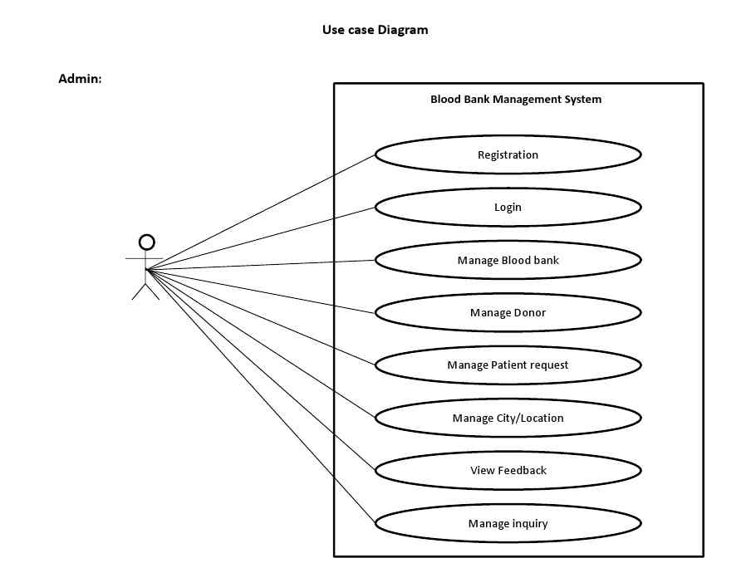Monitors system-wide activities.
2. **Blood Bank Staff**
   * Responsible for managing **donor registration**, **inventory updates**, and **blood unit tracking**.
   * They interface directly with donors and handle physical blood donations.

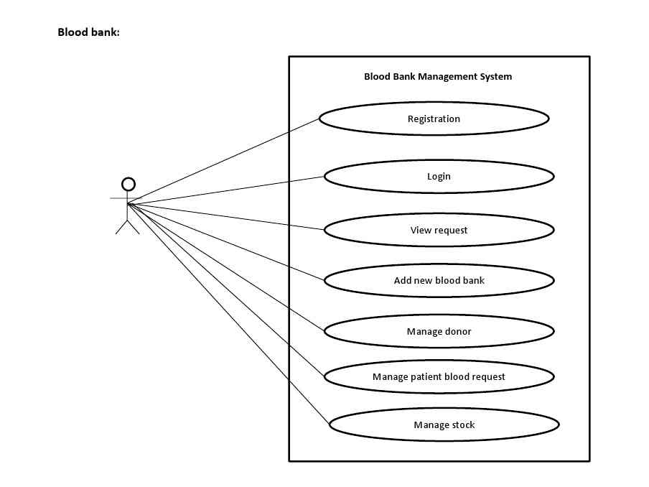

1. **Donor**
   * A voluntary blood contributor who can log into the system to access their **donation history**, **eligibility**, and **personal profile**.
   * 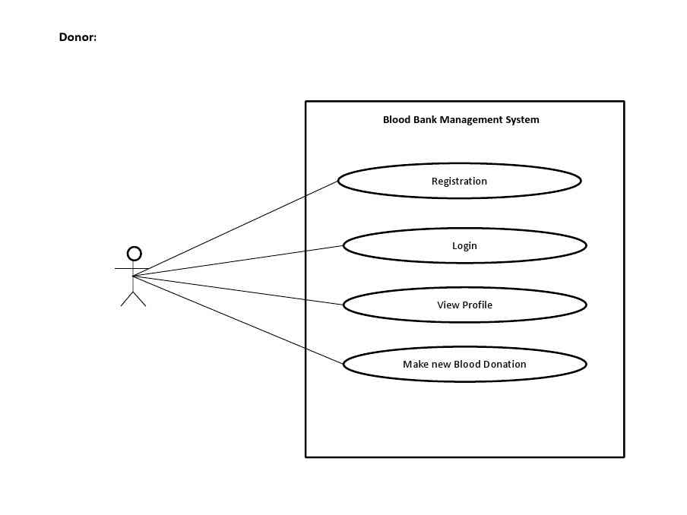May receive reminders, alerts, or thank-you messages via the notification system.

## **4.3.2 Activity Diagram**

An **activity diagram** describes the **workflow** or **process flow** in the system. For BDMS, the most critical activity is **blood request and fulfillment**.

### **Activity: Blood Request by Hospital Department**

**Steps:**

1. Hospital staff logs in.
2. Opens request form.
3. Enters blood type, quantity, urgency.
4. System checks stock availability.
5. If available → move to approval process.
6. Blood bank staff approves.
7. Inventory updates.
8. Blood is dispatched.
9. Status is updated to "Fulfilled".

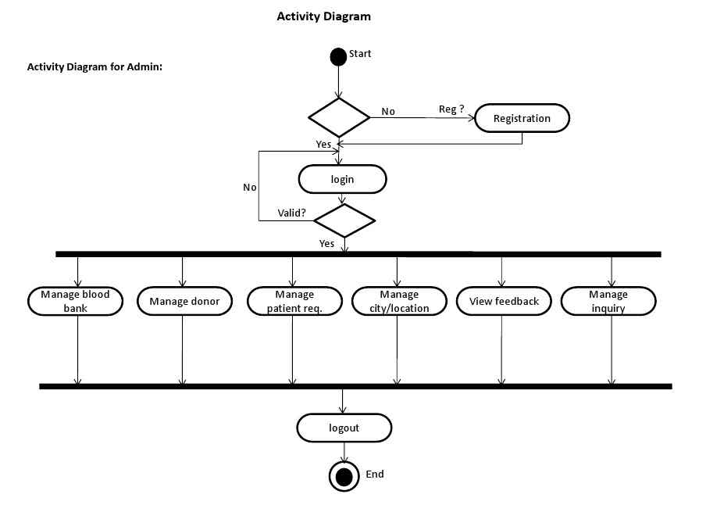

## **4.3.3 Sequence Diagram (Expanded)**

A **sequence diagram** models the **order of interactions** between users and the system. It shows **who does what and when**, with time flowing top-down.

### 📍 **Scenario: Donor Registration and Notification**

**Actors:** Donor → Registration Form → Server (PHP) → Database → Notification Service

**Flow:**

1. Donor fills registration form.
2. Form sends data to server.
3. Server validates and saves data in the database.
4. Server checks last donation date.
5. If eligible, adds to donor list.
6. Sends confirmation message.

## **Admin Activity Diagram**

### 🔹 **Role Summary:**

The Admin oversees the entire BDMS system. They manage users, send alerts, generate reports, and monitor system performance. Admins ensure that the system is functioning securely and efficiently.

1. **Start**  
   The admin opens the system via the secure login page.
2. **Login**  
   Admin enters username and password. The system validates credentials and grants access.
3. **Access Dashboard**  
   The dashboard shows key metrics: number of donors, active users, pending blood requests, inventory level by blood type, etc.
4. **Manage Users**
   * Admin can add new users (e.g., new blood bank staff), assign roles (Admin, Donor, Request Officer), or deactivate accounts.
   * This ensures role-based access control.
5. **Generate Reports**
   * Admin selects report type: Monthly Donation Report, Inventory Status, Expired Units, etc.
   * Chooses filters like date range, blood type, or department.
   * The report is generated and exported in PDF or Excel.
6. **Send Notifications**
   * Admin composes messages (e.g., “Emergency: Need O− blood today!”).
   * Targets a recipient group (e.g., all O− eligible donors).
   * System sends SMS or email and logs it.
7. **Log Out / End**
   * Admin securely logs out.



## 2. **Blood Bank Staff Activity Diagram**

### **Role Summary:**

They interact directly with donors and inventory. They register new donors, record blood units, manage blood stock, and approve hospital requests.

### **Step-by-Step Workflow:**

1. **Start → Login**  
   Staff logs into the system via secure credentials.
2. **Register Donor**
   * Opens donor registration form.
   * Inputs donor's name, age, gender, blood type, contact info, and health conditions.
   * System checks if the donor is eligible based on age, health, and donation interval.
   * Donor is added with a unique Donor ID.
3. **Record Blood Donation**
   * After donation, staff inputs:
     + Blood type
     + Quantity
     + Collection date
   * System auto-generates an expiry date (typically 42 days after collection) and updates inventory.
4. **View Blood Requests**
   * Staff opens the “Pending Requests” dashboard.
   * Each request shows blood type, quantity, urgency, and department.
5. **Approve or Reject Request**
   * System checks current inventory.
   * If sufficient units exist:
     + Staff clicks “Approve.”
     + System updates request status to “Approved.”
   * If not:
     + Staff may reject or place it on hold, and enter comments.
6. **Update Inventory**
   * For approved requests, system deducts units from inventory.
   * Units are marked as “Dispatched.”
7. **Send Notification to Department**
   * System sends a fulfillment notice to the hospital unit.
8. 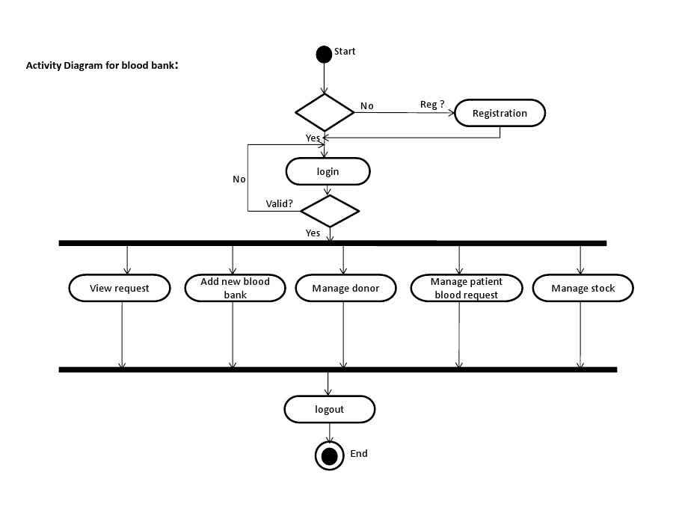**Log Out / End**

## 3. **Donor Activity Diagram**

### 🔹**Role Summary:**

The donor is the heart of the system. They log in, manage their profile, view donation history, and respond to notifications for upcoming or urgent donation needs.

### **Step-by-Step Workflow:**

1. **Start → Register or Login**
   * First-time donors register through the hospital interface.
   * Returning donors log in using their ID or phone number.
2. **View Profile**
   * Donor sees personal information, donation history, blood type, and next eligibility date.
3. **Update Profile**
   * Donor updates contact information like phone or email to receive alerts.
4. **Receive Notification**
   * System sends automated SMS/email when:
     + Donor becomes eligible again (e.g., 3 months after last donation)
     + Emergency blood is needed of their type
5. **Decide to Donate**
   * Donor checks eligibility and decides to go to the hospital.
6. **Visit Hospital and Donate**
   * Physical donation is conducted.
   * Blood Bank Staff records the donation and updates the donor’s last donation date.
7. 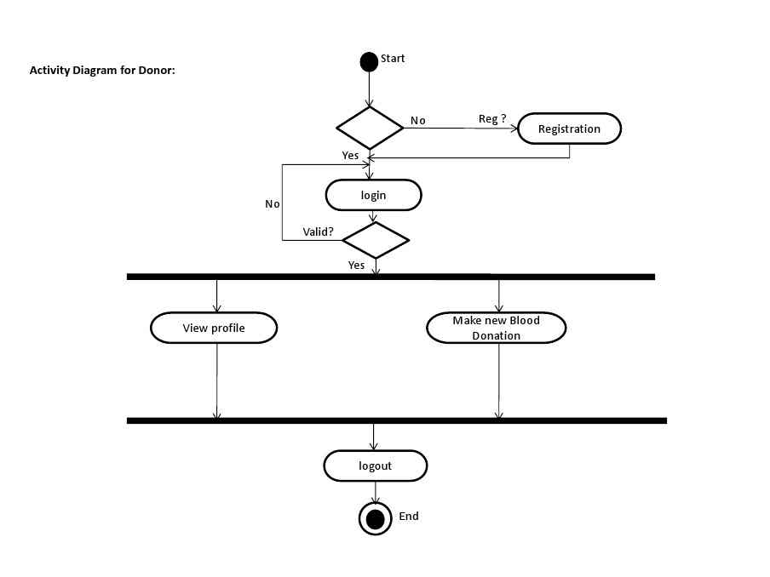**Log Out / End**

## 4. **Hospital Department (Request Officer)**

### 🔹 **Role Summary:**

Staff from hospital departments (e.g., surgery, maternity) can submit requests for blood on behalf of patients and track progress.

### **Step-by-Step Workflow:**

1. **Start (Login)**  
   Department officer logs in securely.
2. **Open Request Form**  
   Enters request details:
   * Blood type
   * Quantity
   * Patient condition (optional)
   * Urgency level
3. **Submit Request**
   * System records the request as “Pending.”
   * Notification is sent to the Blood Bank staff.
4. **Wait for Approval**
   * Staff sees live status updates:
     + Pending → Approved / Rejected
     + Fulfilled (when dispatched)
5. **Receive Notification**
   * System notifies when blood is ready.
   * Department prepares for patient transfusion.
6. **Confirm Usage / End**
   * In future enhancements, department staff can confirm that the unit was used, improving reporting and transparency.

## Conclusion of Activity Diagram

Each actor in the system performs distinct but interconnected actions. The **activity diagrams ensure**:

* Each process is **structured and traceable**
* Roles are **clearly defined**
* The **workflow is secure, efficient, and transparent**

## **4.3.4 Class Diagram**

The **class diagram** shows how the system is structured **in terms of objects and their relationships**. It is used during **object-oriented programming design**.

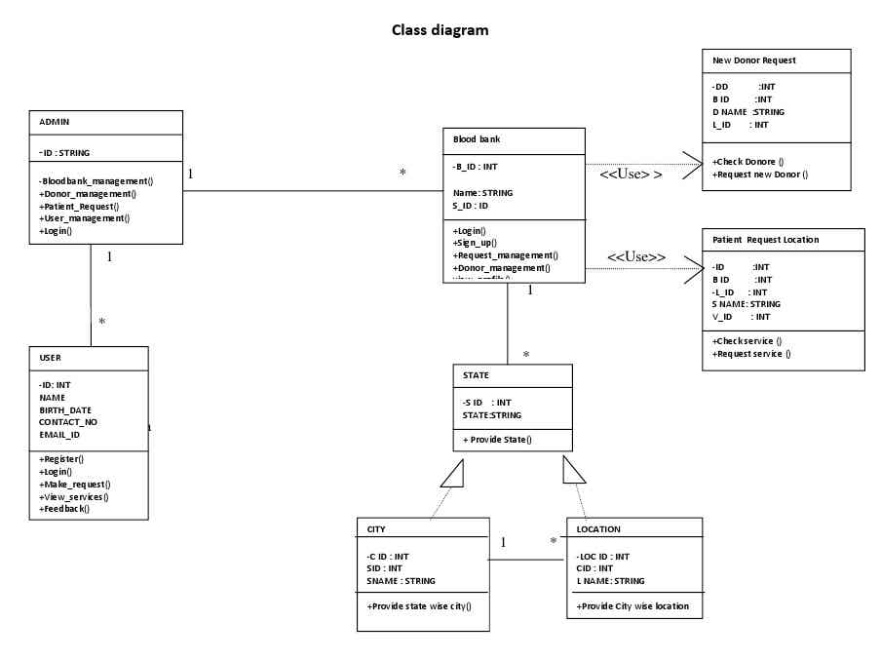

## **4.3.5 Entity Relationship Diagram (ERD – Expanded)**

An **ERD** shows **database structure**: how tables (entities) relate to each other. It is key for designing a **relational database**.

### Main Tables/Entities:

1. **Donors**
   * donor_id (PK), name, blood_type, age, phone, last_donation_date
2. **Inventory**
   * unit_id (PK), blood_type, expiry_date, donor_id (FK), status
3. **Requests**
   * request_id (PK), blood_type, quantity, department, status
4. **Users**
   * user_id (PK), username, password, role
5. **Notifications**
   * notif_id (PK), recipient_id, message, sent_date

**Relationships:**

* One **Donor** → Many **Blood Units**
* One **Request** → Assigned to Many **Blood Units**
* One **Admin** → Sends Many **Notifications**

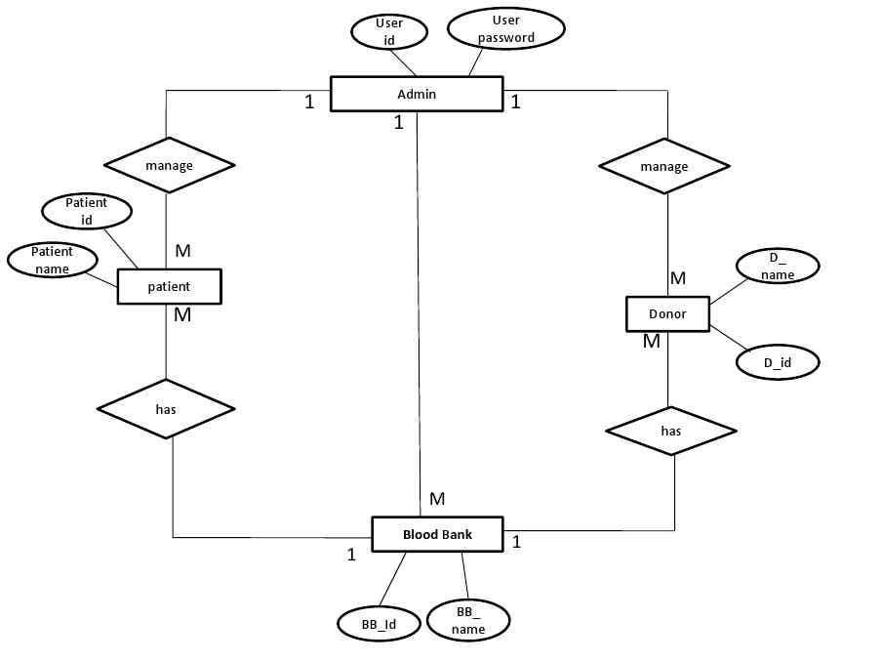

## **4.3.6 Data Flow Diagram (DFD)**

### **DFD Level 1: Blood Request Process**

Blood Donors

Receiving

Services

Donating

Blood

Blood Seekers

**External Entities:**

* Hospital Department
* Blood Bank Staff

**Processes:**

1. Submit Request
2. Check Inventory
3. Approve or Reject
4. Update Inventory
5. Notify Status

**Data Stores:**

* Donor Database
* Inventory
* Requests
* Notifications

**Blood**

**Bank**

**Blood**

**Donors**

**Blood**

**Seekers**

**Registration**

**Login Check**

**Details**

**Modification**

**Donor**

**Search**

**Life**

**Saving**

**Contacts**

**Mobilink**

**Paging**

**Services**

**FAQs**

**General**

**Information**

**Terms Of**

**Service**

### **Main Use Cases**

Blood Donors

Life Saving Contacts

Mobilink Paging Services

Donor

Registration

Donating

Blood

Donor

Search

Blood Seekers

Receiving

Services

Receiving

Information

Services

Register

# **CHAPTER FIVE:**

# **SYSTEM IMPLEMENTATION AND TESTING**

This chapter focuses on how the system was **built, deployed, and tested**. It typically includes:

## **5.1 Introduction**

This chapter provides a detailed breakdown of how the Blood Donation Management System (BDMS) was **developed, tested, and deployed** to meet the needs of Kibitoke Hospital. The implementation phase involved **transforming the system design (from Chapter Four) into a working application**, while the testing phase ensured that the system meets all functional and non-functional requirements. Every module was carefully implemented and verified to ensure **usability, security, accuracy, and reliability** in a healthcare setting.

## **5.2 Development Environment and Tools**

This section outlines the **technical environment and tools** used to build the system. The choice of tools was based on their **open-source availability, ease of integration, lightweight nature, and suitability for a developing-country context** like Burundi.

### **5.2.1 Fronted Development**

* **HTML5**: Used to define the structure of each web page (forms, tables, menus, buttons). It ensures the user interface is standard-compliant and works across browsers.

**Example**: A blood request form was created using HTML input fields like:

### **5.3 System Implementation**

You break down how the system was built module by module:

#### 5.3.1 Donor Registration Implementation

* How the form was created
* Validation (age limits, duplicate ID prevention)
* Insertion into the database

#### 5.3.2 Inventory Module

* How blood units are stored in the database
* How expiry alerts work

#### 5.3.3 Hospital Request Module

* How hospital staff submit requests
* The approval workflow logic

#### 5.3.4 Notification System

* Email or SMS integration
* Automatic vs manual messages

### **5.4 System Testing**

Describe how you tested the system for errors, functionality, and performance.

#### 5.4.1 Testing Approaches

* **Unit Testing**: Testing individual components like registration or login.
* **Integration Testing**: Making sure modules (e.g., donor registration + inventory) work together.
* **System Testing**: Running the entire application end-to-end.
* **User Acceptance Testing (UAT)**: Allowing Kibitoke Hospital staff to test and give feedback.

#### 5.4.2 Test Results

* Include a **test case table**: input, expected output, actual output, pass/fail
* Describe major **bugs found and how they were fixed**

### **5.5 Deployment**

How the system was deployed for use:

* Deployment location (on-premises, localhost, or remote server)
* Steps taken to install and configure
* Users trained and manuals provided

### **5.6 Challenges Faced During Implementation**

Be honest and reflective here:

* Internet interruptions during development
* Difficulty in collecting real-time hospital data
* Compatibility issues between PHP version and MySQL

### **5.7 Summary**

Wrap up the chapter by emphasizing that the system was **successfully developed, tested, and deployed**, and is now ready for **practical use by Kibitoke Hospital**.

Would you like me to now go ahead and **fully write Chapter 5 using your tech stack (PHP, MySQL, JS, XAMPP, VS Code)**?

Excellent! Below is a **highly detailed and fully expanded version** of **Chapter Six: Summary, Conclusion, and Recommendations** for your Blood Donation Management System project. Each section and sub-point is explained with examples and clear illustrations, maintaining the deep, analytical style we've used in earlier chapters.

# **CHAPTER SIX**

# **SUMMARY, CONCLUSION AND RECOMMENDATIONS**

## **6.1 Summary of the Study**

This project set out to **design, develop, and implement** a **Blood Donation Management System (BDMS)** for **Kibitoke Hospital**, a public health facility located in Kibitoke Province, Burundi. The goal was to **address the inefficiencies of manual blood donation operations** and enhance the safety, speed, and organization of blood donation and request processes.

The study followed a **logical and structured research and development process**, which can be summarized as follows:

### **Chapter One: Introduction**

* Presented the **background**, highlighting how Kibitoke Hospital relied on **manual methods** for managing blood donors, which caused **delays in emergency responses, loss of donor records, and difficulty tracking inventory**.
* Defined the **problem statement**, objectives (main and specific), research questions, and scope.
* Justified the need for a **digitally supported system** to save time, minimize errors, and improve donor engagement.

### **Chapter Two: Literature Review**

* Reviewed previous studies on blood donation systems in countries like Nigeria, India, and Pakistan.
* Identified that many successful systems incorporate features such as:
  + **Automated donor eligibility tracking**
  + **Real-time inventory monitoring**
  + **Hospital-to-blood bank request integration**
* Recognized gaps in **security, cross-hospital integration, and donor engagement**, which this study aimed to address.

### **Chapter Three: Methodology**

* Adopted a **qualitative research approach** using **interviews, observations, and system analysis** at Kibitoke Hospital.
* Collected firsthand data from donors, staff, and administrators.
* Used the **Waterfall Software Development Life Cycle (SDLC)** model for system development:
  1. Requirement gathering
  2. System design
  3. Implementation
  4. Testing
  5. Deployment

### **Chapter Four: System Analysis and Design**

* Defined **functional and non-functional requirements** of the BDMS.
* Developed system models:
  + **Use Case Diagram** showing how users interact with the system
  + **Entity Relationship Diagram (ERD)** showing database structure
  + **Data Flow Diagram (DFD)** illustrating processes
* Described the **system architecture** (three-tier: frontend, backend, and database).
* Created user interface mockups for modules like donor registration and blood requests.

### **Chapter Five: System Implementation and Testing**

* Described the actual **coding, development, and testing** of the system.
* Built using:
  + **Frontend**: HTML, CSS, JavaScript
  + **Backend**: PHP
  + **Database**: MySQL via XAMPP
* Implemented modules such as:
  + Donor registration
  + Inventory tracking
  + Hospital blood requests
  + Automated alerts
* Conducted thorough testing (unit, integration, and user acceptance testing).
* Deployed the system in a local environment and conducted training for hospital staff.

## **6.2 Conclusion**

The development and implementation of the **Blood Donation Management System for Kibitoke Hospital** represents a **significant step forward in improving healthcare delivery** in Burundi’s public hospitals. This system has succeeded in addressing several key problems that were prevalent in the hospital’s manual system.

### **Key Achievements:**

1. **Improved Donor Record Management**
   * Donor information is now **securely stored in a centralized digital database**.
   * Easy retrieval reduces search time from hours to seconds.
2. **Real-Time Inventory Visibility**
   * Staff can now view **exact quantities of blood units by type and expiry date**, making it easier to allocate and request.
3. **Streamlined Blood Request Process**
   * Hospital departments no longer need to rely on handwritten requests or phone calls.
   * The digital request module ensures requests are **submitted, reviewed, approved, and tracked** systematically.
4. **Donor Engagement Enhanced**
   * Automated notifications ensure **repeat donations** from eligible donors.
   * Staff can **send campaigns during emergencies**.
5. **Security and Role-Based Access**
   * User authentication and role assignments ensure that only authorized personnel can access sensitive information.
   * Different users (donor, staff, admin) have different levels of access, reducing errors and protecting privacy.
6. **Data Integrity and Reporting**
   * Accurate records support **monthly and annual reporting** for hospital management and the Ministry of Health.

### **Overall Impact:**

The system helps Kibitoke Hospital move from a **paper-based, reactive approach** to a **proactive, digital-first model**, ensuring **faster decisions, improved safety, and better patient outcomes** during emergencies.

## **6.3 Recommendations**

Based on the outcomes of this project and observations during testing and staff training, the following recommendations are made for further improvement and sustainability of the system:

### **6.3.1 Full Adoption and Continuous Use**

The hospital administration should:

* **Officially adopt the BDMS as the standard tool** for managing all blood-related activities.
* Make its use **mandatory for all hospital staff** involved in donor handling, inventory, and blood requests.
* Assign an **IT focal person or system administrator** to oversee day-to-day usage and support.

Illustration: During UAT, several staff reported that after just one training session, they could already register a donor in less than 2 minutes—this indicates readiness for full adoption.

### **6.3.2 Feature Expansion**

To increase functionality and accessibility, future versions should:

* **Include mobile compatibility** so that donors can access their profiles or receive messages on their smartphones.
* Integrate an **SMS gateway or email API** to automate real-time alerts, especially during emergency appeals.
* Allow **donor pre-registration online** to reduce congestion during blood drives.

Illustration: In times of disaster or accident spikes, the system could send bulk SMS messages like:  
“URGENT: Kibitoke Hospital needs O− blood donors today. Please visit the blood bank if you’re eligible.”

### **6.3.3 Regional Expansion**

Since this system has proven effective in Kibitoke Hospital, it should be **replicated in other hospitals** across Burundi, especially in areas with high accident rates or maternal health risks.

* Encourage the **Ministry of Health** to consider this as a **pilot model** for a national rollout.
* Set up **cloud-based hosting** to allow shared access by multiple hospitals in a province.

Illustration: If another hospital in Bujumbura runs low on B+ blood, they could query Kibitoke’s database and request a transfer—enabled through future system interconnection.

### **6.3.4 Regular Maintenance and Support**

To ensure sustainability:

* Assign a **dedicated IT officer** or outsource support to regularly monitor system health.
* Conduct **quarterly audits** of system logs to detect issues early.
* Update the software regularly to incorporate:
  + Security patches
  + Improved user features
  + Bug fixes reported by staff

Illustration: A weekly backup schedule should be automated to ensure no data is lost in case of power failure or hardware crash.

### **6.3.5 Further Research and Innovation**

This project lays the foundation for future enhancements. Suggested directions include:

* **Machine learning integration** to predict future blood demand based on hospital trends.
* **QR-code or biometric scanning** for quick donor identification.
* **Multilingual support** to make the system accessible to non-French speakers (e.g., Kirundi, Swahili).

Illustration: A machine learning model could learn that “December has more blood usage due to traffic accidents,” and suggest proactive blood collection in November.

## **6.4 Final Remarks**

The successful development of the Blood Donation Management System proves that **simple, low-cost digital tools can transform healthcare delivery** in resource-limited settings. This project demonstrates:

* That a **local need can be solved using local knowledge and open-source tools**.
* That staff can easily transition to **technology-based workflows** when systems are designed to match their real processes.
* That **information technology is essential** in saving lives by improving the speed and accuracy of healthcare responses.

With this system in place, **Kibitoke Hospital now has a reliable, transparent, and secure tool** to manage one of the most critical aspects of patient care—**the availability of safe blood**.

**REFERENCES**

1. Ahmed, S., Khan, M., & Raza, A. (2020). Enhancing efficiency in blood banks through automation: A case study of India. International Journal of Blood Services, 12(2), 134-145.
2. Adebayo, O., Nwachukwu, E., & Adekunle, T. (2021). Digital transformation in healthcare: An evaluation of Nigeria's eBlood Donation System. Journal of Healthcare IT, 15(3), 234-245.
3. Gupta, R., & Singh, P. (2021). Data security challenges in developing countries: A study on healthcare institutions. International Journal of Cybersecurity & Healthcare, 10(1), 88-102.
4. Karim, M., & Hossain, M. (2022). Evaluating the impact of automated blood bank systems on hospital efficiency in Bangladesh. South Asian Journal of Medical Technology, 8(4), 67-83.
5. Smith, J., & Johnson, L. (2019). Improving donor retention through digital engagement: Lessons from high-income and low-income settings. Global Blood Bank Review, 20(1), 45-60.
6. Would you like me to proceed with Chapter 4 (System Analysis & Design) and include ERD, DFD, and UML diagrams? Let me know if you need any modifications!